Screenshot
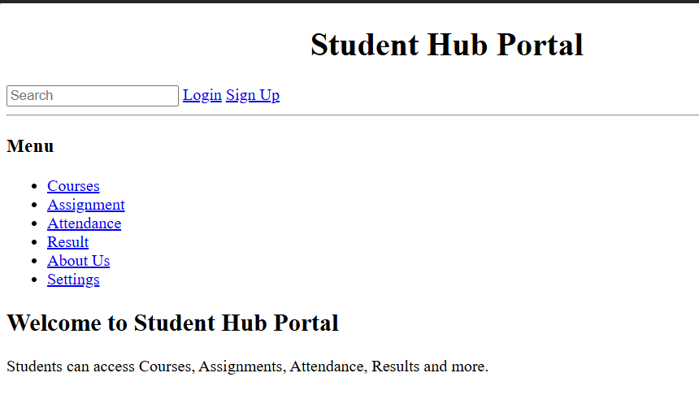
Description: This figure shows the StudentHub Home Page created using HTML5 semantic elements. The page contains a header with the StudentHub title, a navigation menu, main content sections, and a footer. The navigation links provide access to other pages of the StudentHub portal
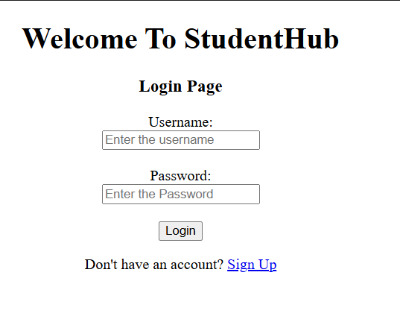
Description: This figure shows the StudentHub Registration/Login Page containing accessible form elements. Each input field is associated with a proper label, making the form easier to understand and use with assistive technologies. The page follows the same header, navigation, and footer structure used throughout the StudentHub website.
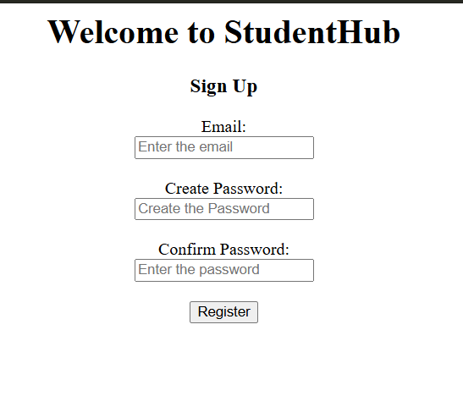
Description: This figure shows the StudentHub Sign Up page. It contains fields for entering the user's email, creating a password, and confirming the password. A Register button is provided to submit the registration form. The page has a clear and simple structure for new users to create an account.
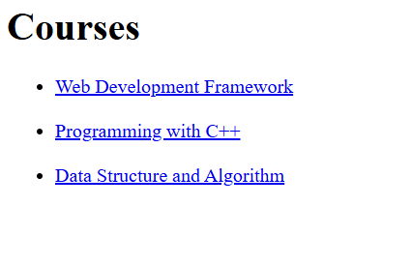
Description: This figure shows the Courses page of the StudentHub portal. It displays a list of available courses, including Web Development Framework, Programming with C++, and Data Structure and Algorithm. Each course is presented as a clickable link that allows the user to view its details.
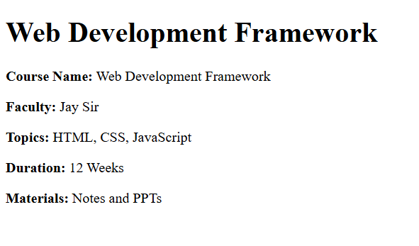
Description: This figure shows the Web Development Framework course details page. It provides information such as the course name, faculty, topics, duration, and study materials. The topics covered are HTML, CSS, and JavaScript, with a duration of 12 weeks.
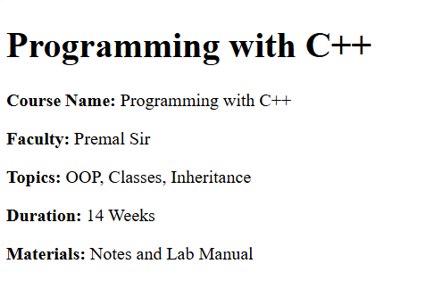
Description: This figure shows the Programming with C++ course details page. It displays the course name, faculty, topics, duration, and available materials. The main topics include OOP, Classes, and Inheritance, and the course duration is 14 weeks.

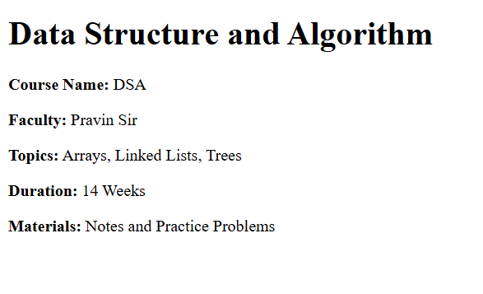
Description: This figure shows the Data Structure and Algorithm (DSA) course details page. It provides information about the course name, faculty, topics, duration, and study materials. The topics include Arrays, Linked Lists, and Trees, with a duration of 14 weeks.

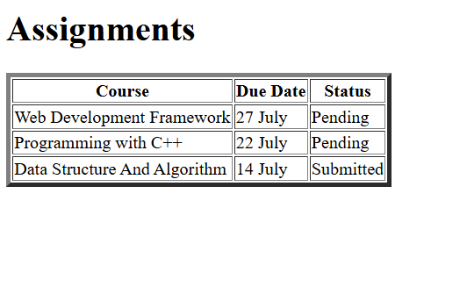
Description: This figure shows the Assignments page of the StudentHub portal. It contains a table displaying the course name, assignment due date, and submission status. The assignments are listed for Web Development Framework, Programming with C++, and Data Structure and Algorithm, with their respective statuses shown as Pending or Submitted.
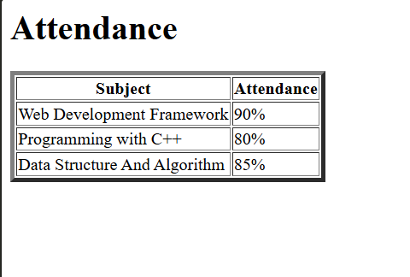
Description: This figure shows the Attendance page. It presents the attendance percentage for different subjects in a table. The attendance is shown as 90% for Web Development Framework, 80% for Programming with C++, and 85% for Data Structure and Algorithm.
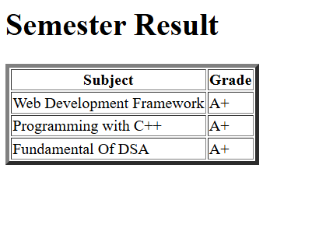
Description: This figure shows the Semester Result page of the StudentHub portal. It displays the subjects and corresponding grades in a table. The listed subjects—Web Development Framework, Programming with C++, and Fundamental of DSA—all have an A+ grade.
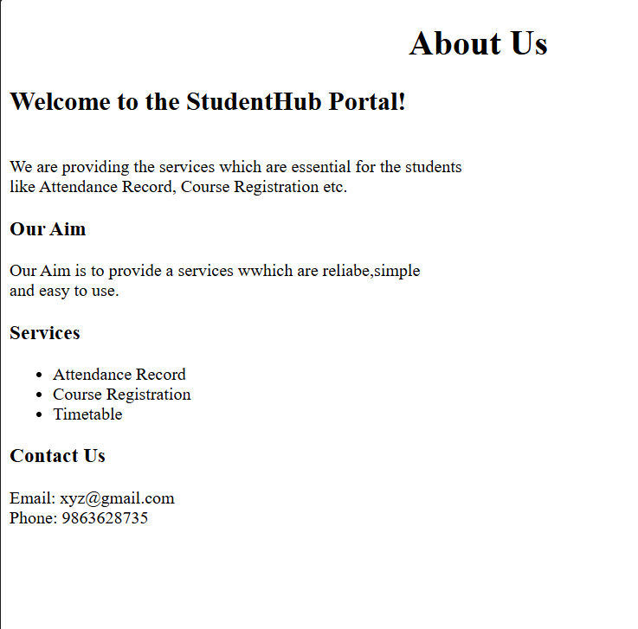
Description: This figure shows the About Us page of the StudentHub portal. It introduces the purpose of the portal and describes the services provided to students. The page includes sections for Our Aim, Services, and Contact Us. The services include Attendance Record, Course Registration, and Timetable, along with email and phone contact information.
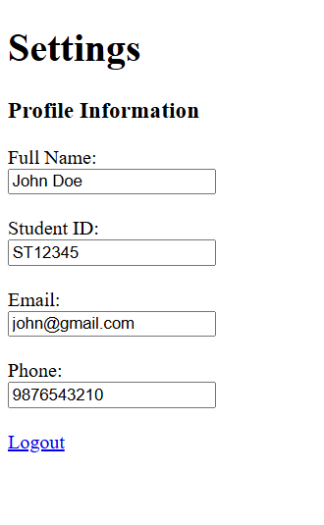
Description: This figure shows the Settings page of the StudentHub portal. It contains a Profile Information section with fields for the user's full name, student ID, email, and phone number. A Logout link is also provided so that the user can securely exit their account.

